Read Now: Relative Formula Mass (Mr) Date:23/01/2026
Every element has a number that tells us how heavy one atom is.
This number is called the relative atomic mass, or Ar.
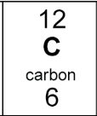
Ar = mass of ONE atom
12 is the Relative Atomic Mass (protons + neutrons)
You can find the Ar on the periodic table, it is the bigger number.

Examples:
- Carbon has an Ar of 12
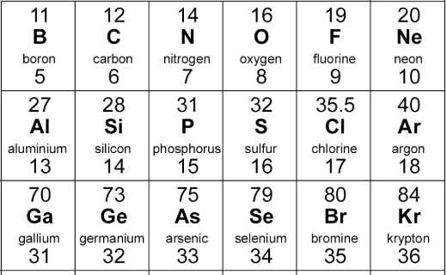
- Oxygen has an Ar of 16
- Sulfur has an Ar of 32
- Aluminium has an Ar of 27

Remember
- Ar → elements
- One number → one atom
- Comes from the periodic table

Questions
1. Multiple choice
What does Ar stand for?
A. Atomic radius B. Relative atomic mass C. Atomic number D. Relative amount
2. Fill in the gap: The mass of one atom of an element is called ________ ________ ________.
3. Fill in the gap: Ar is the mass of ______ atom.
4. What is the relative atomic mass of sulfur?
5. What is the relative atomic mass of Bromine?
6. Carbon has an Ar of 12 and oxygen has an Ar of 16.
A molecule contains: 1 carbon atom and 2 oxygen atoms
Calculate the total mass of the molecule
Answer the following questions.
- Circle the correct word to complete the sentence.

  - Relative atomic mass can also be written as M_{r} / A_{r}
  - Relative formula mass can also be written as M_{r} / A_{r}
  - The relative atomic mass of an element / compound can be found using the Periodic Table

  - The relative atomic mass can be found next to the chemical symbol, on a Periodic Table, and it is always the bigger / smaller / top / bottom number.

- State the relative atomic mass for the following elements:

  - Nitrogen
  - Bromine
  - Neon
  - Thallium
  - Vanadium
  - Helium
- Calculate the relative formula mass of each of the following compounds.
Show your working.
  - Cl₂
  - H₂
  - H₂O
  - CO₂
  - HCl
  - CuSO₄
  - NaOH
  - Al₂O₃
  - Zn(OH)₂
  - Mg(NO₃)₂

  - Ca(HCO₃)₂

  - (NH₄)₂SO₄

- A metal oxide has the formula MO, where M is the chemical formula for the metal and O is oxygen.
The relative formula mass for this compound is 40.
What is the metal?

